|  |  |  |  |
| --- | --- | --- | --- |
|  | 4/12/2015 |  | |
|  | |  | |
| ADMD Report  *Coursework 2/2* | | | |
|  |  | |  |
|  |  | | Vo Minh Nhut |

|  |  |
| --- | --- |
| Student Name : | Vo Minh Nhut |
| ID Number : | GC60222 |
| Greenwich ID # : | Vn6073s |
| Class : | GC0763 |
| Course : | ADMD |

Table of Contents

Exercise 1 - App Inventor exercise based on the PaintPot tutorial exercise 2

1. Basic Information 2

2. Exercise answer 2

Exercise 2 - App Inventor exercise based on the MoleMash tutorial example 4

1. Basic Information 4

2. Exercise answer 5

Exercise 3 - Investigation of "Android API level" 6

1. Basic Information 6

2. Exercise answer 6

Exercise 4 - Add a button and Activity to the NameEntry App 7

1. Basic Information 7

2. Exercise answer 7

Exercise 5 - Create an Android App to calculate overtime pay. 10

1. Basic Information 10

2. Exercise answer 11

Java File : 14

Layout File : 14

String Resource File : 16

Exercise 6 - SQLite database exercise 17

1. Basic Information 17

2. Exercise answer 17

# Exercise 1 - App Inventor exercise based on the PaintPot tutorial exercise

## Basic Information

|  |  |
| --- | --- |
| 1.1 How well did you complete the exercise? Tick as appropriate. | * I did everything that was asked |
| 1.2 Briefly explain your answer to question 1.1 |  |

## Exercise answer

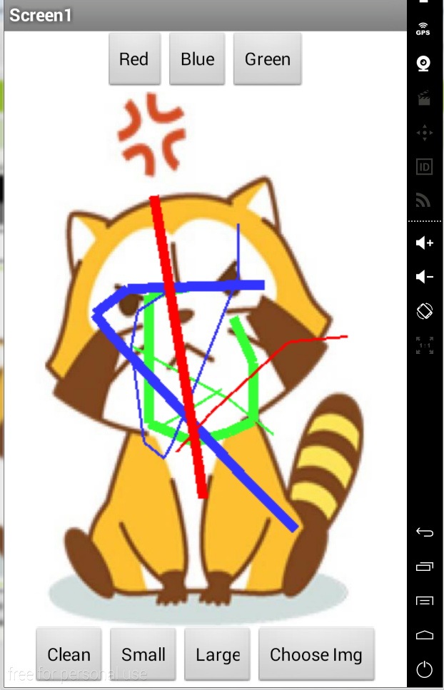

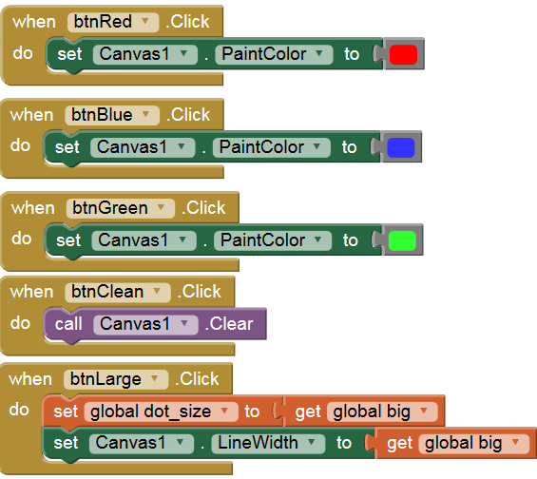

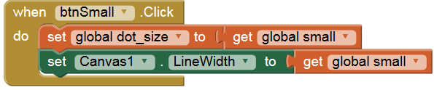

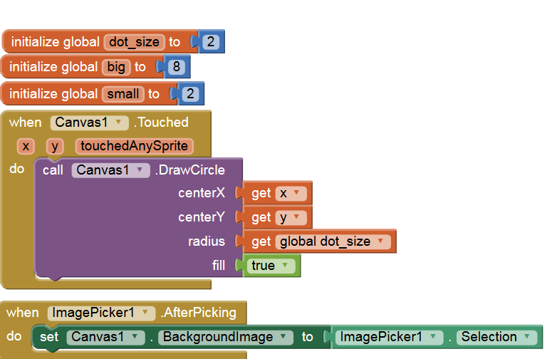

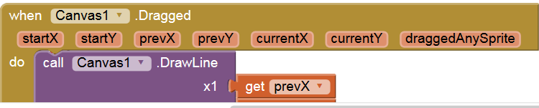

# Exercise 2 - App Inventor exercise based on the MoleMash tutorial example

## 1. Basic Information

|  |  |
| --- | --- |
| 1.1 How well did you complete the exercise? Tick as appropriate. | * I did everything that was asked |
| 1.2 Briefly explain your answer to question 1.1 |  |

## 2. Exercise answer

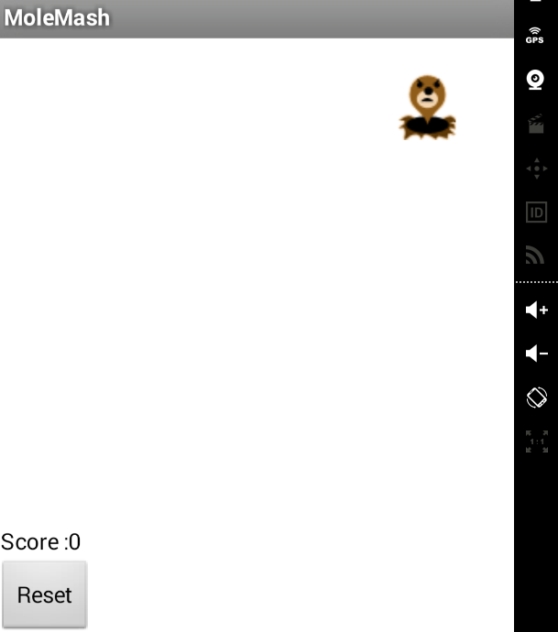

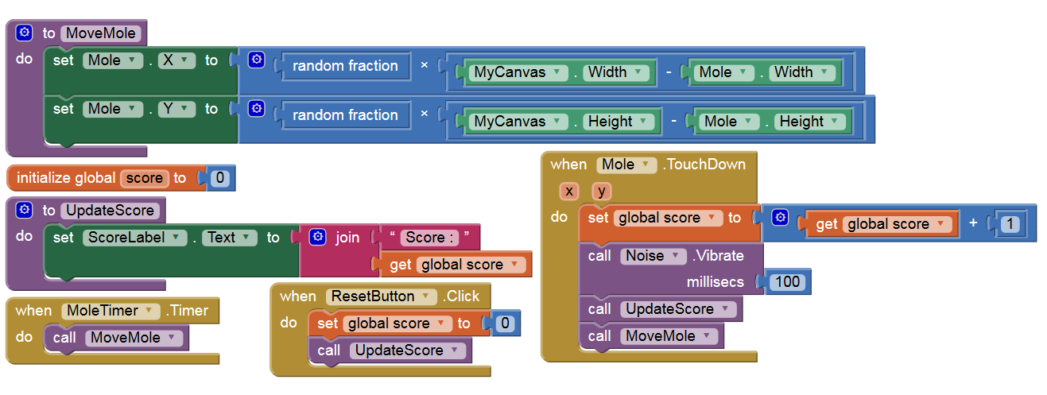

# Exercise 3 - Investigation of "Android API level"

## Basic Information

|  |  |
| --- | --- |
| 1.1 How well did you complete the exercise? Tick as appropriate. | * I did it but I feel I should have done better |
| 1.2 Briefly explain your answer to question 1.1 |  |

## Exercise answer

According to the research that I have made, there are several ways that Android OS is labeled. It’s either identified by version numbers, code names or also by API levels.

Android Platform Version is the traditional way of naming a platform, it’s an incremental decimal number that bases on the developing progress of the platform itself. On the other hand, API level is the identical number that indicates which version of Android SDK is matched with which version of Android Platform. Furthermore, as the API level grown, many new methods and functions had been added to the new API level. Another thing is there is the fact that only the devices that run the platform version which is compatible with the new API level or a higher one can accesses the applications which target that API level.

In general, we can see that each version of Android platform support a specific API level and because of its inheritance, the platform also supports the previous API levels too. As the very latest version of Android Platform is 5.1 (Lollipop) which goes with API level 22 supports all of the previous level back to the very first level 1.

# Exercise 4 - Add a button and Activity to the NameEntry App

## 1. Basic Information

|  |  |
| --- | --- |
| 1.1 How well did you complete the exercise? Tick as appropriate. | * I did everything that was asked |
| 1.2 Briefly explain your answer to question 1.1 |  |

## 2. Exercise answer

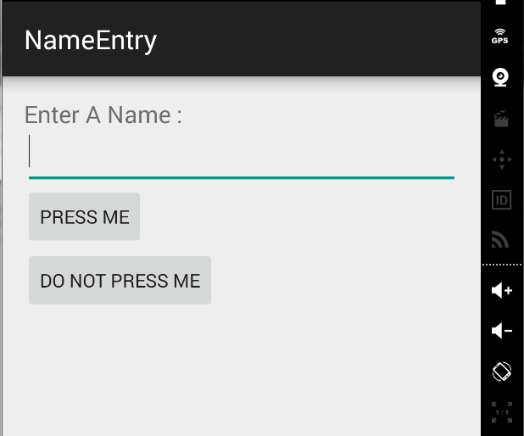

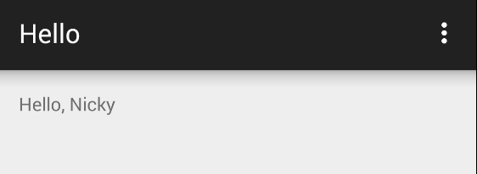

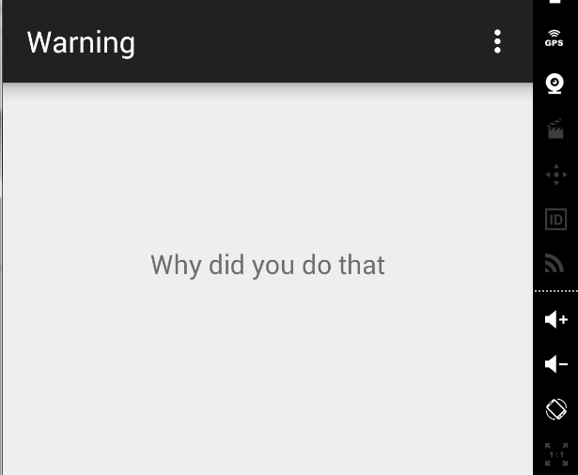

Java File: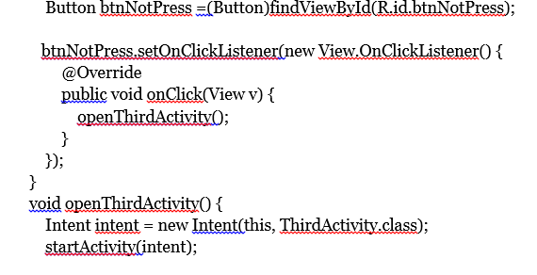 }

### 

### Layout File:

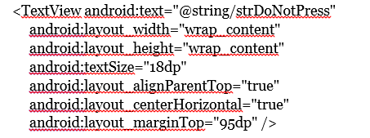

### String resource file:

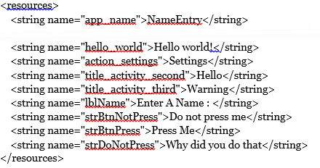

# Exercise 5 - Create an Android App to calculate overtime pay.

## 1. Basic Information

|  |  |
| --- | --- |
| 1.1 How well did you complete the exercise? Tick as appropriate. | * I did everything that was asked |
| 1.2 Briefly explain your answer to question 1.1 |  |

## 2. Exercise answer

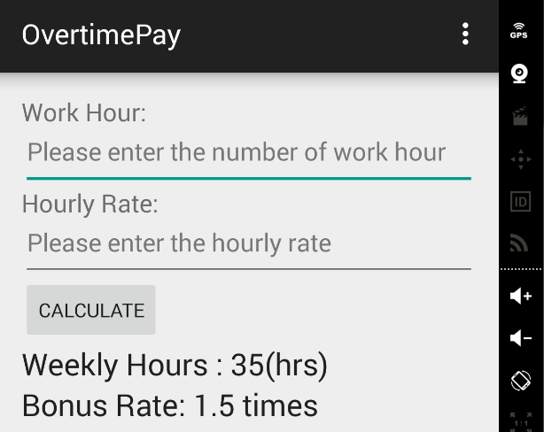

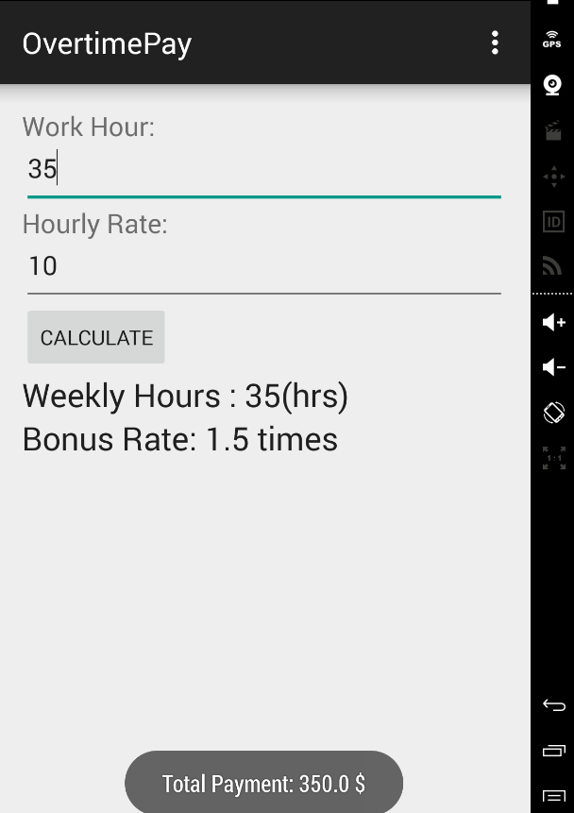 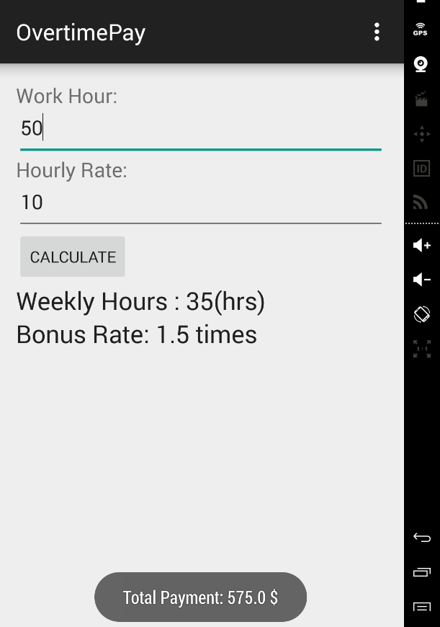

### Java File :

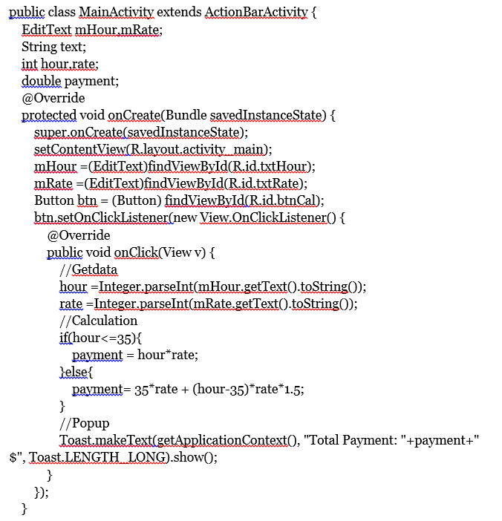

### Layout File :

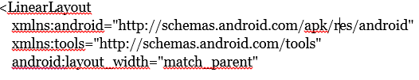

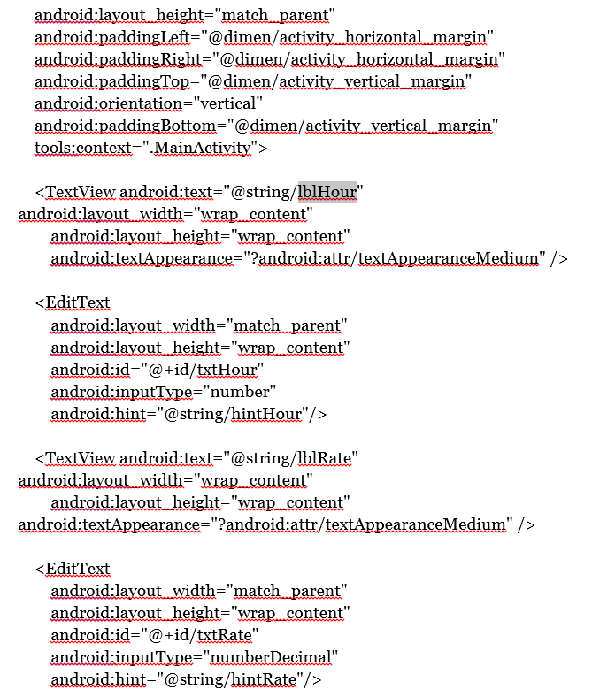

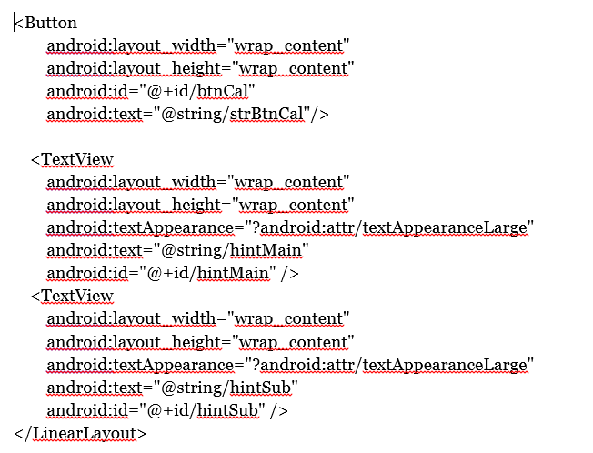

### String Resource File :

# 

# Exercise 6 - SQLite database exercise

## 1. Basic Information

|  |  |
| --- | --- |
| 1.1 How well did you complete the exercise? Tick as appropriate. | * I tried but couldn't complete it * I did it but I feel I should have done better * I did everything that was asked * I did more than was asked for |
| 1.2 Briefly explain your answer to question 1.1 |  |

## 2. Exercise answer

* Screen shots demonstrating your program working
* Copy and paste the code you had to write to complete the exercise